Start of sprint

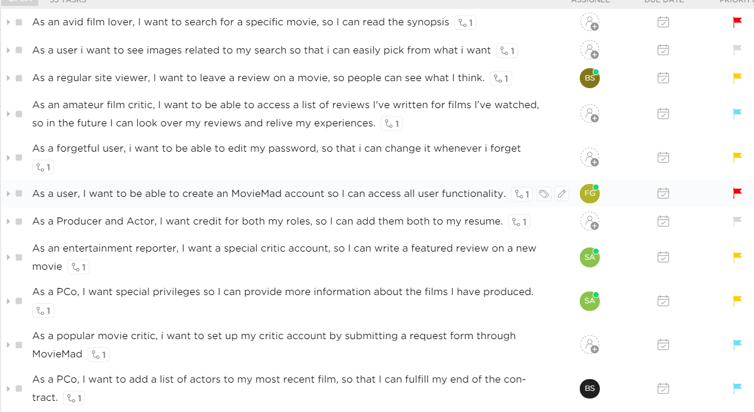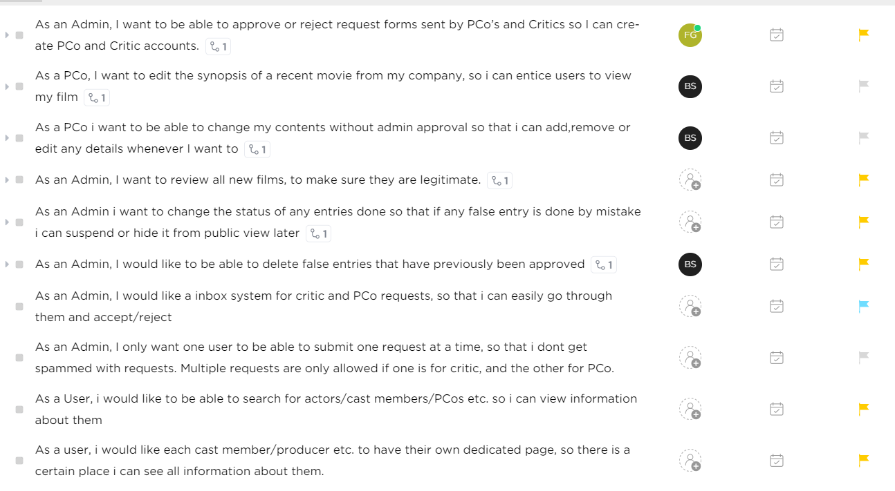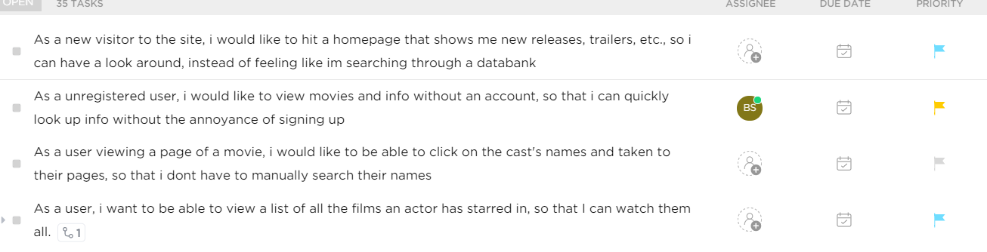

Midway 1





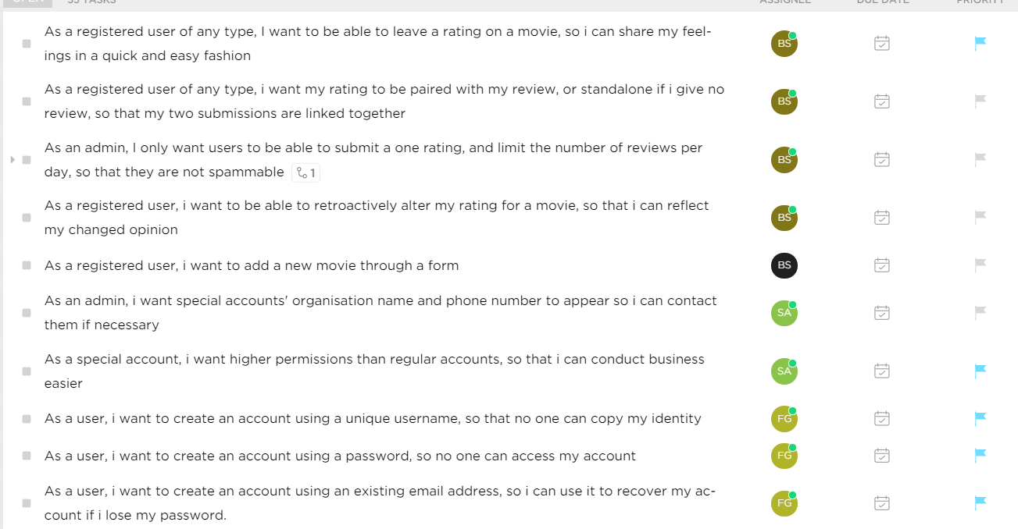

### The other midway screenshot and the final screenshots are the same as midway 1, so no reason to include them.